Does an E cigarette minimum legal sale age law reduce smoking of combustible cigarettes?

***Rayyan Saad Mobarak***

**Abstract**

An approximate 480,000 deaths occur in the US per year due to smoking, with vaping products coming into the US in 2007. This paper examines the relationship between regulating the E cigarette market with a minimum legal sale age (MLSA) law and the consumption of combustible cigarettes for the youth population. Using data gathered from CDC and BLS, I use fixed effects OLS models and found a lower average consumption of regular cigarettes for states when MLSA was active compared to when it was not. These results are strongly significant when time fixed effects are excluded. When including time fixed effects, the results continue to be negative but no longer significant. When excluding a few key outlying states, the results continue to be negative with varying levels of statistical significance. Since I did not find any positive correlation, the results suggest that the US regulation of the E cigarette market are not promoting consumption of the more harmful combustible cigarettes for the youth population.

**1)** **Introduction**

An approximate 480,000 deaths occur in the US per year due to smoking even though there is global awareness about its harmful effects (Kenkel 2016 ; Kenkel, Peng, Pesko and Wang 2017). With the first electronic cigarette being developed in China, the US market saw the advent of vaping products in 2007. Gradually more and more flavors of the vape were introduced and it created two significant markets within the smoking industry. In 2014 teen use of E cigarettes had surpassed any other tobacco product (Governing 2019). Therefore, consumer welfare loss depends on the health impacts of the advent of E cigarettes. Since E cigarettes do not burn tobacco, they are said to be less harmful than combustible cigarettes (Buckell, Marti and Sindelar 2017). The burning of vapor in E cigarettes causes no second-hand smoke externality and is also devoid of tar, making it safer than regular cigarettes (Buckell, Marti and Sindelar 2017). However, high amounts of nicotine can kill and can hamper brain development making E cigarettes have negative health consequences as well (Kenkel 2016).

The question arises as to the relationship between the market for combustible cigarettes and vaping products. Are they substitutes with smokers switching to vaping, are they complements where there is dual use, or are the two trends unrelated? This relationship is hard to accurately identify given the available data. But from a policy standpoint, it is important to understand this since regulations of one of the markets might affect consumption in the other. Therefore, this empirical paper will examine the hypothesis that regulations on E cigarettes in the form of a minimum legal sale age (MLSA) law will correlate to lower consumption of regular cigarettes.

The paper is structured as follows. Section 2 conducts a literature review of previous studies. Section 3 outlines my data collection and summarizes key variables of the dataset. Section 4 outlines my econometric equation and section 5 showcases my corresponding results and robustness checks. Finally, I draw my conclusion in section 6 along with an evaluation of my methods and an ideal experiment for my research question.

**2) Literature Review**

Before we can investigate the relation between E cigarettes and combustible cigarettes, we would need to look at studies into how consumers perceive E cigarettes in terms of risk and how effective it is as a cessation device. Given that E cigarettes are a relatively new product, it is likely that consumers are not fully aware of its costs and benefits.

A cross sectional study between E cigarette and conventional cigarette smoking used survey data from the National Youth Tobacco Survey (NYTS) for 2011 and 2012 and probability models to figure out the odds of youth engaging in smoking regular cigarettes based on whether they had smoked conventional cigarettes (Glantz and Dutra 2014). They find that having smoked E cigarettes significantly increases the chances of smoking conventional cigarettes later in life. A similar longitudinal study derives data from a national study of adolescents with a logistic regression to model how E cigarette consumption translates to combustible cigarettes (Fine, Primack, Sargent, Stoolmiller and Soneji 2015). They found that use of E cigarettes at baseline progresses to traditional cigarette smoking suggesting some intertemporal complementarity.

However, we can see conflicts as well. A discrete choice experiment finds consumers overestimating risks of E cigarettes, and then substituting more of conventional cigarettes for E cigarettes (Kenkel, Hughes, Pesko and Wang 2016). Another survey study comes to the same conclusion of net welfare loss caused by consumers not choosing E cigarettes due to overestimated risks (Viscusi 2016).

Using data from an online survey a discrete choice experiment was devised reflecting purchases of “BLU” a leading E cigarette distributor (Siegel, Tanwar and Wood 2011) .The findings suggest evidence that E cigarettes are an effective smoking cessation tool (Siegel, Tanwar and Wood 2011). These results have been replicated in other countries as well including New Zealand and Italy (Bullen and McRobbie 2014). They used a randomized control trial comparing E cigarettes with nicotine and E cigarettes without nicotine in helping quitting smoking. They find nicotine is important as a cessation device when people try to quit smoking.

Some empirical studies exist which looks at how the relationship between the markets can be tested using inconvenience costs in the form of the MLSA law, as a proxy for E cigarette prices. This is the method used by my paper. One study uses NYTS data from 2009 to 2014 along with logistic regression on lagged models (Arrazola, Dutra, Glantz and King 2018). However, they did not find any significant effect of smoking rates from MLSA laws on E cigarettes. In support of E cigarettes and combustible cigarettes as substitutes, we find 3 studies supporting this claim. Abigail S. Friedman uses smoking rates from National Survey on Drug Use and Health (NSDUH) with smoking rates of 12 to 17-year old as the dependent variable. Results show E cigarette access reduces teen smoking and the E cigarette bans have caused an increase in smoking rates. Another 2016 study compares MLSA laws to cigars, smokeless tobacco and marijuana in addition to cigarettes by using state level data from the Youth Risk Behavior Surveillance System (YRBSS)**,** they find MLSA laws increase regular cigarette use by 0.8 percentage points, really close to Friedman’s study of a 0.9 percentage point increase (Faisal, Hughes and Pesko 2016). The third study looks at birth outcomes of pregnant teenagers after MLSA laws have affected combustible cigarette consumption (Currie and Pesko 2016). They find MLSA laws have increased youth smoking rates.

Conflict arises due to studies establishing complementarity between the markets as well. MTF surveys of high school students from 2007 to 2014 were analyzed within log regression models (Adams and Abouk 2017). The study found that E cigarettes and combustible cigarettes are complements for adolescents for 30-day smoking prevalence, but there is no significant relationship in terms of the frequency of cigarettes smoked. This relates back to Soneji and Primack’s 2015 study which finds that consumption of E cigarettes promotes traditional cigarette smoking.

**3) Data**

*a. Collection*

I use smoking data from the State Tobacco Tracking and Evaluation (STATE) system of the Centers for Disease Control and Prevention which is an interactive application allowing obtainment of historical data on the use of tobacco and its prevention. My dataset includes information on all 50 states and the District of Columbia, with the time period for each state being from 2007 to 2018 forming a panel dataset. I begin my analysis at 2007 since that is when E cigarettes had entered the US market.

For my dependent variable, I look at cigarette consumption. This is represented by cigarette sales (pack per capita). Data on this has been provided to CDC by Orzechowski and Walker (OW), an economic consulting firm (CDC). This is the “Y” variable I aim to explain using my estimating equations, regression tables and visualizations.

For my variable of interest, I retrieved the minimum age provision of E cigarettes from CDC, which had been provided by the Office of Health and Smoking (OHS). These laws have been enforced by factors including penalty to youth and/or penalty to businesses which have different categories such as fines, community service, etc. Most states enforce this policy by enacting these factors in conjunction, while a few states might enact these in isolation (OHS, CDC). While I have monthly data on when the law came into place, I have treated the variable as yearly[1] since the time period of my analysis is in years.

My control variables are retrieved from both CDC and the Bureau of Labor Statistics (BLS). I use state tax per pack of cigarettes as a control variable (OW, CDC) since this has a large influence on cigarette consumption and so it should be controlled for (Friedman 2015). Another variable is whether Medicaid covers smoking cessation, which is an extension made within states to cover the quitting of smoking (CDC, MMWR). This will aim to reduce smoking related diseases and medical costs (CDC, MMWR). I retrieved this data from the Lung Association who has provided the data to the CDC STATE system (CDC). While there are categories behind this coverage, such as fee for service plans and managed care plans, CDC provides their own recommendation of whether states have undergone this extension or not, which is what I use as my variable. A Medicaid control variable had been used in one study from my literature, but for birth outcomes rather than smoking cessation (Pesko and Currie, 2016).

I use three more variables for my estimation which are unemployment rate, median household income and percentage of bachelor’s graduates all retrieved from Geofred (BLS, Geofred). These control variables have been used extensively in the literature, in order to isolate the effects of the variable of interest within the estimation (Adams and Abouk 2017; Dutra, Glantz, Arrazola and King 2018; Dave and Pesko 2018). Lastly, I do not use E cigarette taxes as a control variable since as of 2018, Minnesota is the only state to have enacted this (Dave and Pesko 2018).

*b. Data Summary*

Let us first look at how cigarette consumption is distributed within our dataset. Figure 1 below shows a kernel density estimate of cigarette consumption within the data.

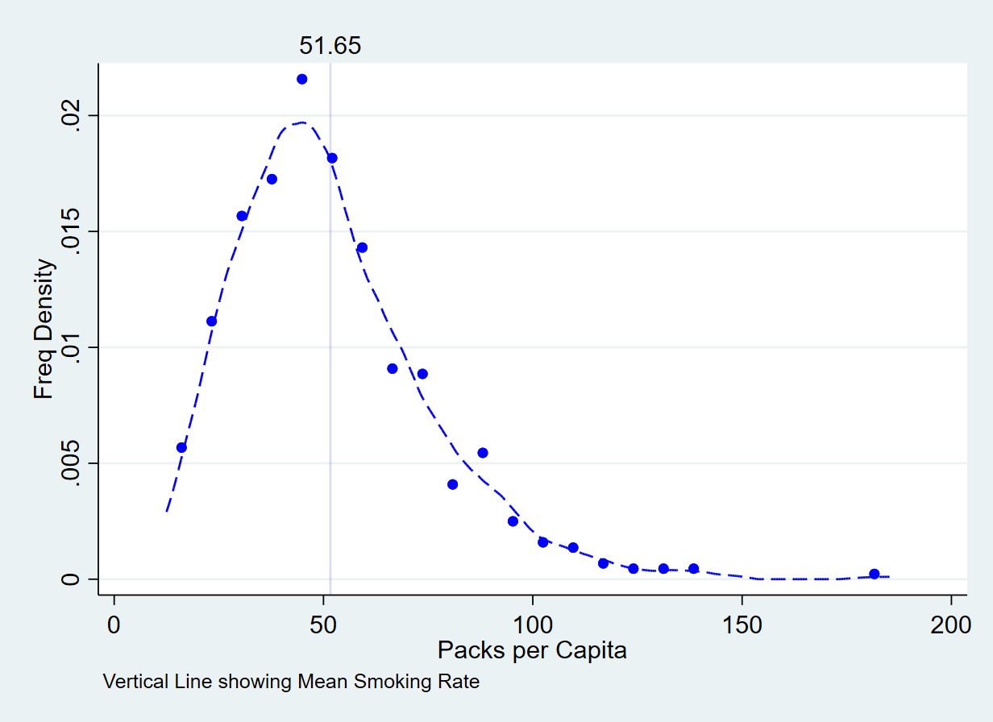

**Figure 1: Kernel Density of Cigarette Consumption**

We can see that the distribution of cigarette consumption is right skewed in nature. Most of our observations of smoking rates is concentrated between 20 to approximately 80 packs per capita. The vertical line illustrates the average smoking which is at 51.65 packs per capita. It would be interesting to see the behavior of this when separated by the presence of an MLSA law. Figure 2 below illustrates the kernel density of smoking rates separated by this.

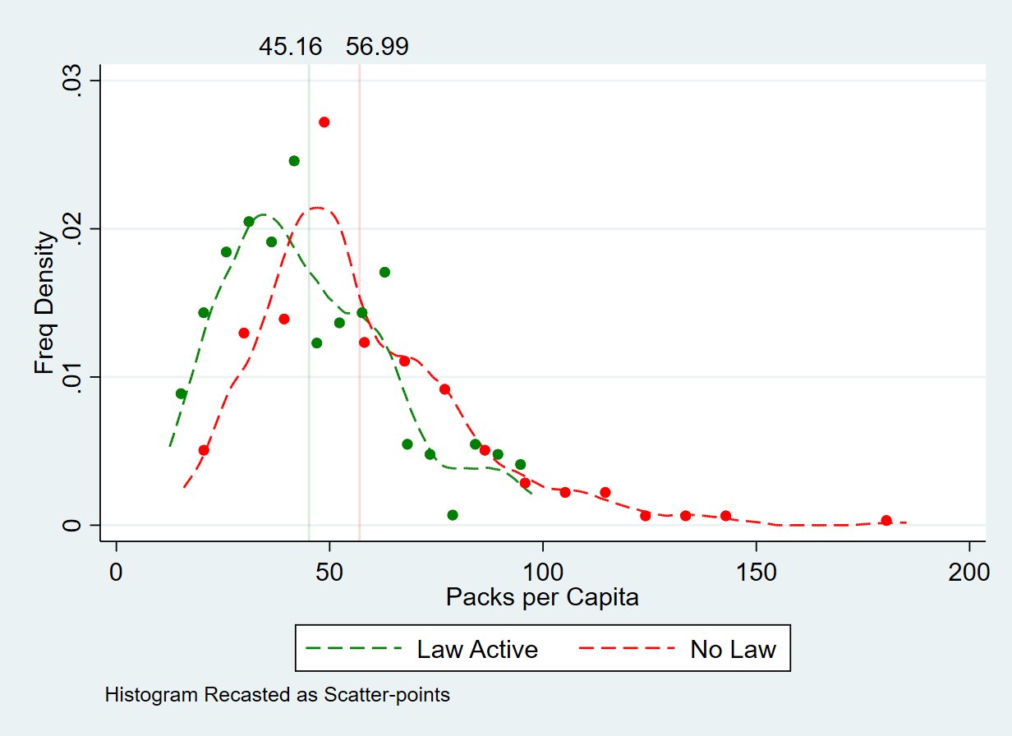

**Figure 2: Kernel Density Separated by MLSA**

Once separated by MLSA, we can see that the density functions continue to be right skewed and behave like the aggregate. When the law is active, however, we can see the density curve showing lower smoking rate observations due to the curve being shifted left from when no law was in place. This leads to the average smoking rate to be lower at 45.16 packs per capita as compared to the 56.99 when no law was in place.

While the lower average smoking rate for when the law was active is interesting, it is important to know how the MLSA laws behave over time. It is possible that there might be a downward time trend in smoking behavior which would lead to information other than the MLSA law being captured within the averages. We can see this trend by looking at smoking behavior over time for each state. Figure 3 below illustrates this.

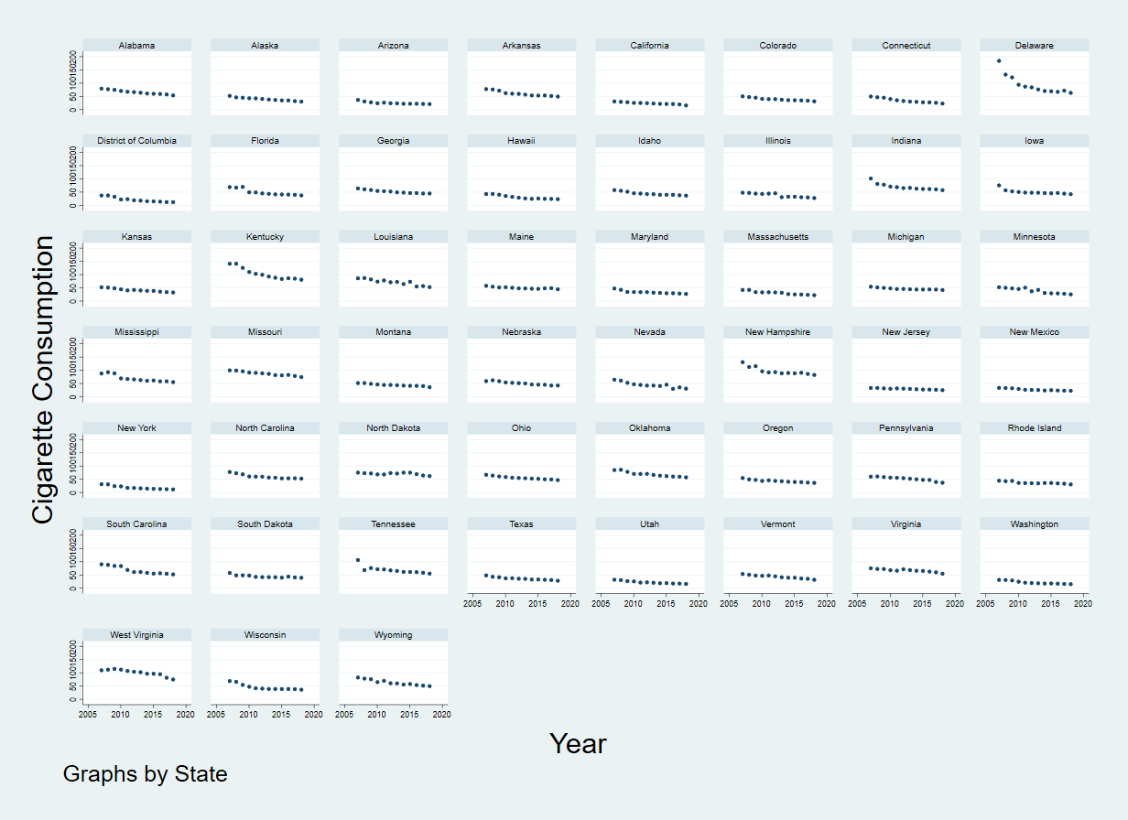

**Figure 3: Smoking Rates over Time by State**

Over time, smoking rates have gone down across all states. It is important to control for this variation in order to truly isolate the effects of the MLSA law by using time fixed effects. By looking at how the MLSA laws are distributed over time, we would be able to see if this yearly trend coincides with when the law came into effect. Figure 4 illustrates how the three types of MLSA laws have behaved over the study period.

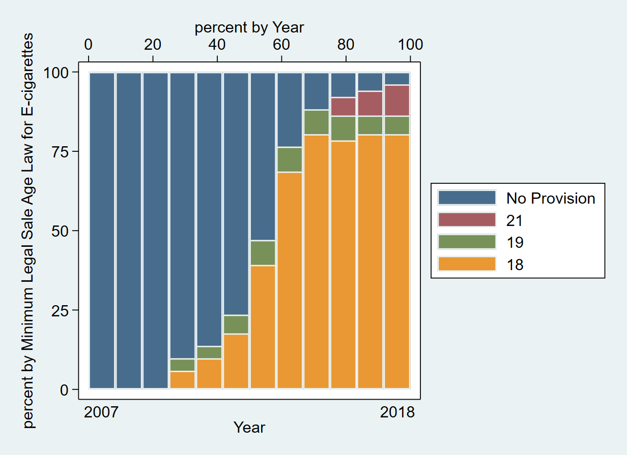

**Figure 4: MLSA Laws over Time**

We can see that for the first three years of the period none of the states had any such laws in place. From 2010 onwards we can see laws starting to take effect. The MLSA of 18 continues to increase throughout time till 2018. We can see a small decrease in 2016, which could signify some states which have had a law of 18 years have become stricter by changing to years of 19 or 21. By 2018, almost all states had MLSA laws in place with most of the observations being 18 years.

**4) Econometric Specification**

In order to estimate whether the MLSA law decreases cigarette smoking, I use the following time and state fixed effects[2] regression model:

CigCsy = β0 + β1 Usy+  β2 MDHsy +  β3 Taxcigsy +  β4 Edusy + αs+ ૪y+ λ0MEDsy + λ1MLSAsy + εsy

CIgC is the smoking rate of regular cigarettes in terms of sales of packs per capita. The s and y subscripts are indexes indicating observations for some state and year. The variables Usy, MDHsy, Taxcigsy, Edusy denote the unemployment rate, median household income, state cigarette tax per pack and percentage of bachelor's degrees respectively. MEDsy represents if a Medicaid expansion has occurred and takes the value of 1 for the states that have enacted it during the expansion period, and 0 otherwise. αs and ૪yare vectors representing state and year fixed effects respectively. MLSAsy is the variable of interest which is 1 for a state when they had first devised the age law of 18, 19 or 21 and for all years after that. Therefore, this variable is 0 for the years that tge states had not enacted the law yet, and it is completely 0 for Michigan and Pennsylvania who had never enacted an MLSA law. The λ1 coefficient measures the estimated impact of the MLSA law on smoking rates. Finally, εsy is the stochastic error term.

**5) Results**

1. *Basic Estimation*

Table 1 first illustrates the regression results, excluding the time fixed effects. This would allow for comparison once the time trend has been controlled for. Control variables are gradually added across the five columns of the table.

My control variables have for the most part, signs I expect from the literature. Cigarette taxes have a significant negative slope across models 2 to 5, which is consistent with the downward sloping demand of the regular cigarette market. Education has a significant negative slope in Models 4 and 5 where it is used as a control variable. The variable “MDH” is Median household income which has a positive but small slope. The unemployment rate has a negative slope, even though it is expected that increases in unemployment rates usually translates to more smoking. However, it is possible to find disparities with these signs since there is multicollinearity between unemployment rates, median household income and education.

Our variable of interest is “MLSA_law”. We can see in table 1 below, this variable has a negative coefficient across all specifications. The negative coefficient reflects that when the MLSA law is in place, the per capita average cigarette consumption is lower compared to the average consumption when the law was not in place, when controlling for all other covariates. This coefficient ranges from 13.07 to 4.573 from models 1 to 5, which reflects the magnitude by which the smoking rates in packs per capita is lower. These are significant at the 1% level across the four models. As more control variables that are correlated with cigarette consumption are added, we can see that the coefficient value keeps decreasing.

It is important to note that in Model 5, the number of observations has decreased from 612 to 553 observations. This is because no data was available for 2007 for the Medicaid provision of smoking cessation. This is also not a variable that has been used by papers within my literature. However, I believe this factor is correlated with cigarette consumption and is important to control for within the regression analysis.

|  |  |  |  |  |  |
| --- | --- | --- | --- | --- | --- |
|  | (1) | (2) | (3) | (4) | (5) |
| VARIABLES | Model 1 | Model 2 | Model 3 | Model 4 | Model 5 |
|  |  |  |  |  |  |
| MLSA_law | -13.07*** | -10.76*** | -11.99*** | -4.969*** | -4.573*** |
|  | (0.677) | (0.694) | (0.777) | (0.868) | (0.723) |
| Cig Tax |  | -7.519*** | -7.486*** | -2.970*** | -4.104*** |
|  |  | (0.890) | (0.888) | (0.852) | (0.796) |
| Unemp rate |  |  | -0.474** | -0.863*** | -0.331* |
|  |  |  | (0.209) | (0.185) | (0.177) |
| MDH |  |  | 0.000121 | 0.000456*** | 0.000311*** |
|  |  |  | (0.000101) | (9.24e-05) | (7.76e-05) |
| Education |  |  |  | -3.575*** | -2.704*** |
|  |  |  |  | (0.275) | (0.253) |
| Medicaid |  |  |  |  | 0.403 |
|  |  |  |  |  | (0.913) |
| Constant | 57.55*** | 67.67*** | 63.80*** | 141.0*** | 121.4*** |
|  | (0.440) | (1.268) | (6.742) | (8.370) | (7.660) |
|  |  |  |  |  |  |
| Observations | 612 | 612 | 612 | 612 | 553 |
| R-squared | 0.400 | 0.468 | 0.479 | 0.601 | 0.606 |
| Number of id | 51 | 51 | 51 | 51 | 51 |
| r2_o | 0.0649 | 0.360 | 0.341 | 0.351 | 0.410 |
| r2_b | 0.000361 | 0.378 | 0.358 | 0.316 | 0.351 |
| r2_w | 0.400 | 0.468 | 0.479 | 0.601 | 0.606 |
| F | 372.9 | 245.6 | 128.1 | 167.5 | 127.4 |
| F_f | 88.43 | 62.09 | 61.57 | 76.08 | 88.16 |
| rho | 0.881 | 0.853 | 0.860 | 0.900 | 0.918 |

**Table 1: State Fixed Effects Estimation**

As outlined, previously the MLSA laws came into effect at later points in time within the study period. It is likely the estimates of MLSA presented in table 1, overstate the coefficient and the correlation between the variables. Therefore, time fixed effects are also added to the specifications in table 2 below. The intercepts of each year are suppressed in order to save space. The control variables are added in the same order across the five models like table 1.

Firstly, we can see that the MLSA laws continue to show negative coefficients across the four models. The average per capita cigarette consumption continues to be lower when the MLSA laws are in place compared to when they are not. However, we can see that all coefficients have decreased in magnitude compared to table 1. These results are no longer significant which suggests we must accept the null hypothesis that the mean average cigarette consumption was the same when MLSA law is in place compared to when it was not. The coefficient is -1.406 in model 1 and it falls to -1.003 when all controls are introduced. While the significance is lost these estimates are more accurate since the time effect is being controlled for within these models. However, we can see how these results change when a sensitivity analysis is conducted.

|  |  |  |  |  |  |
| --- | --- | --- | --- | --- | --- |
|  | (1) | (2) | (3) | (4) | (5) |
| VARIABLES | Model 1 | Model 2 | Model 3 | Model 4 | Model 5 |
|  |  |  |  |  |  |
| MLSA_law | -1.406 | -1.503 | -1.375 | -1.403 | -1.003 |
|  | (0.974) | (0.971) | (0.971) | (0.973) | (0.762) |
| Cig Tax |  | -1.776** | -1.888** | -1.831** | -2.676*** |
|  |  | (0.795) | (0.795) | (0.802) | (0.705) |
| Unemp rate |  |  | -0.187 | -0.193 | -0.0412 |
|  |  |  | (0.326) | (0.327) | (0.259) |
| MDH |  |  | 0.000186** | 0.000200** | 0.000100 |
|  |  |  | (8.94e-05) | (9.33e-05) | (7.30e-05) |
| Education |  |  |  | -0.251 | 0.658* |
|  |  |  |  | (0.458) | (0.368) |
| Medicaid |  |  |  |  | 0.796 |
|  |  |  |  |  | (0.801) |
| Constant | 67.54*** | 69.44*** | 59.01*** | 64.91*** | 41.94*** |
|  | (0.838) | (1.191) | (5.940) | (12.27) | (10.11) |
|  |  |  |  |  |  |
| Observations | 612 | 612 | 612 | 612 | 553 |
| R-squared | 0.656 | 0.660 | 0.663 | 0.663 | 0.707 |
| Number of id | 51 | 51 | 51 | 51 | 51 |
| r2_o | 0.115 | 0.198 | 0.141 | 0.203 | 0.0161 |
| r2_b | 0.000361 | 0.383 | 0.0521 | 0.307 | 0.0839 |
| r2_w | 0.656 | 0.660 | 0.663 | 0.663 | 0.707 |
| F | 87.40 | 81.65 | 71.50 | 66.97 | 73.32 |
| F_f | 150.5 | 98.52 | 95.54 | 88.68 | 117.8 |
| rho | 0.926 | 0.920 | 0.925 | 0.920 | 0.960 |

**Table 2: State and Time Fixed Effects Estimation**

1. *Sensitivity Analysis*

I investigate how sensitive my results are based on the removal of some key states. Table 3 shows time and fixed effects estimations with the removal of the states of Delaware, Kentucky, Minnesota and Massachusetts and then all states removed across the five models. I include all control variables within each.

I have excluded Delaware and Kentucky since the rates of smoking in the earlier years of my study were much higher. This can be seen in figure 3 above, for these two states. This is because historically these states had high smoking rates and it took some time for tobacco control programs to create effects (CDCTobaccoFree 2018). The results are outlined in models 1 and 2 in table 3. We can see that removing these states does not seem to change the MLSA coefficient greatly. For the exclusion of Delaware and Kentucky we can see average smoking rates are lower for active MLSA laws by 0.957 and 0.948 packs respectively, compared to when no laws were in place. The magnitude continues to be negative and statistically insignificant.

In model 3, I exclude Minnesota since for most of my study period, MN was the only state to have taxes on E cigarettes with just a few more states only enacting them at the end of the study period (Governing 2019). Therefore, MN will have a greater influence on cigarette consumption because of E cigarette taxes. When Minnesota has been excluded the coefficient is now negative 1.328 packs per capita. This coefficient is now significant at the 10% level and continues to be negative, like previous results.

Massachusetts is excluded in model 4 since their MLSA law came into effect county by county before finally covering the whole state in 2018 (Faisal Hughes and Pesko 2016). Like previous results the coefficient is negative at 1.003 packs per capita and insignificant. It seems that this negative relationship holds across all models I have estimated.

Finally, model 5 excludes all states together. The coefficient reflects lower average smoking rates by 1.193 packs per capita when MLSA is in place as compared to no active laws. This is significant at the 5% level. While this suggests a strong correlation within the variables, care should be taken to interpret this result since majority of the results conclude that the coefficient of the MLSA law is not significant from 0.

|  |  |  |  |  |  |
| --- | --- | --- | --- | --- | --- |
|  | (1) | (2) | (3) | (4) | (5) |
| VARIABLES | No Delaware | No Kentucky | No Minnesota | No Massachusetts | All Excluded |
|  |  |  |  |  |  |
| MLSA_law | -0.957 | -0.948 | -1.328* | -1.003 | -1.193** |
|  | (0.657) | (0.701) | (0.778) | (0.762) | (0.581) |
| Cig Tax | -2.636*** | -2.866*** | -2.439*** | -2.676*** | -2.556*** |
|  | (0.606) | (0.646) | (0.761) | (0.705) | (0.566) |
| Unemp rate | 0.00297 | -0.191 | 0.0148 | -0.0412 | -0.101 |
|  | (0.222) | (0.238) | (0.261) | (0.259) | (0.194) |
| MDH | 9.74e-05 | 6.06e-05 | 0.000110 | 0.000100 | 6.64e-05 |
|  | (6.33e-05) | (6.72e-05) | (7.39e-05) | (7.30e-05) | (5.56e-05) |
| Education | 0.515 | 0.699** | 0.663* | 0.658* | 0.560** |
|  | (0.320) | (0.338) | (0.369) | (0.368) | (0.277) |
| Medicaid | 0.574 | 1.552** | 0.770 | 0.796 | 1.298** |
|  | (0.687) | (0.754) | (0.802) | (0.801) | (0.610) |
| Constant | 44.32*** | 42.42*** | 40.99*** | 41.94*** | 43.81*** |
|  | (8.735) | (9.342) | (10.10) | (10.11) | (7.601) |
|  |  |  |  |  |  |
| Observations | 542 | 542 | 542 | 553 | 520 |
| R-squared | 0.749 | 0.729 | 0.705 | 0.707 | 0.785 |
| Number of id | 50 | 50 | 50 | 51 | 48 |
| r2_o | 0.0318 | 0.0261 | 0.00962 | 0.0161 | 0.0331 |
| r2_b | 0.0471 | 0.0474 | 0.108 | 0.0839 | 0.0375 |
| r2_w | 0.749 | 0.729 | 0.705 | 0.707 | 0.785 |
| F | 88.89 | 80.02 | 70.96 | 73.32 | 104.2 |
| F_f | 140.0 | 125.8 | 120.0 | 117.8 | 167.0 |
| rho | 0.968 | 0.962 | 0.961 | 0.960 | 0.973 |

**Table 3: Sensitivity Results**

**6) Limitations and Conclusion**

The ideal experiment in order to ascertain if the MLSA has reduced cigarette consumption is to quantify the cross elasticity of demand between E cigarettes and regular cigarettes. If this can be quantified it would be easy to find out how changes in one market in terms of price or costs would affect consumption in the other market. However, price and consumption data for E cigarettes are not available at a large scale and so the XED cannot currently be quantified. This is a problem faced by most of the studies in my literature which is why I must use inconvenience costs in acquiring E cigarettes such as an MLSA law, as a proxy for the price of E cigarettes. This method was suggested by Abigail Friedman in her 2015 study. Jidong Huang and John Tauras (2014) estimated XED using store scanner price data of E cigarettes from the Nielsen company, a US based data and information firm. But this study is a subset of total E cigarette sales. It also excludes online sales and represents the prices of limited brands. Hopefully in the future more widespread data will be available to estimate a better XED between the products.

While my estimation strategy shows the direction and magnitude of the correlation between MLSA laws and regular cigarettes, it does not tell us if MLSA has caused this reduction in regular cigarette consumption. However, while I cannot provide a causal impact, my results have been negative across all models and specifications. Therefore, at the very least, I did not find any evidence of the MLSA laws correlating to a positive relationship with regular cigarette smoking rates, which would have much higher health costs for the youth population. Another limitation of this study is the fact that the estimating equations does not capture the exact point in time in which the MLSA has been enacted. As mentioned before, if an MLSA was introduced for example in July of 2014, the variable would be 1 for the entire year. This is because I was not able to find cigarette consumption data at a monthly frequency. If I was able to acquire data for my control and dependent variables at a monthly frequency, my estimates might have been more accurate.

In conclusion, I show that an E cigarette MLSA law of correlates to lower smoking rates of regular cigarettes. For the states fixed effects model there is a 4.573 pack decrease, significant at the 1% level. Once time fixed effects are added it is a 1.003 pack decrease and no longer significant. However, this is a much more accurate estimate due to controlling for the time trend of cigarette consumption. Excluding certain states within the analysis maintains a negative relationship but does not change the significance level, until when all outlying states are excluded together where we can see a 1.193 pack decrease, significant at the 5% level. However, this result should be interpreted with caution since this excludes important variation within the data. Based on these results, the MLSA policies on E cigarettes does not seem to promote an increase in consumption of regular cigarette smoking rates. Future research can be directed towards estimating a causal impact of this regulation or conducting an extensive data collection and analysis study to estimate the XED between the products.

**References**:

Abouk, R., & Adams, S. (2017). Bans on electronic cigarette sales to minors and smoking among high school students. *Journal of Health Economics*, *54*, 17–24.<https://doi.org/10.1016/j.jhealeco.2017.03.003>

Amid Vaping Craze, States Push Hefty Taxes. (2019). Retrieved December 10, 2019,

from        <https://www.governing.com/topics/finance/sl-state-taxes-vaping.html>

Buckell, J., Marti, J., & Sindelar, J. (2017). *Should Flavors be Banned in E cigarettes? Evidence on Adult Smokers and Recent Quitters from a Discrete Choice Experiment* (No. w23865; p. w23865).<https://doi.org/10.3386/w23865>

CDCTobaccoFree. (2018, February 6). National Tobacco Control Program. Retrieved December 10, 2019, from Centers for Disease Control and Prevention website:<https://www.cdc.gov/tobacco/stateandcommunity/tobacco_control_programs/ntcp/index.htm>

DiGiulio, A. (2018). State Medicaid Coverage for Tobacco Cessation Treatments and Barriers to

Accessing Treatments—United States, 2015–2017. *MMWR. Morbidity and Mortality Weekly*

*Report*, *67*.<https://doi.org/10.15585/mmwr.mm6713a3>

Dutra, L. M., & Glantz, S. A. (2014). Electronic Cigarettes and Conventional Cigarette Use Among US Adolescents: A Cross-sectional Study. *JAMA Pediatrics*, *168*(7), 610.<https://doi.org/10.1001/jamapediatrics.2013.5488>

Dutra, L. M., Glantz, S. A., Arrazola, R. A., & King, B. A. (2018). Impact of E cigarette Minimum Legal Sale Age Laws on Current Cigarette Smoking. *Journal of Adolescent Health*, *62*(5), 532–538.<https://doi.org/10.1016/j.jadohealth.2017.11.302>

Friedman, A. S. (2015). How does electronic cigarette access affect adolescent smoking? *Journal of Health Economics*, *44*, 300–308.<https://doi.org/10.1016/j.jhealeco.2015.10.003>

Huang, J., Tauras, J., & Chaloupka, F. J. (2014). The impact of price and tobacco control policies on the demand for electronic nicotine delivery systems. *Tobacco Control*, *23*(suppl 3), iii41–iii47.<https://doi.org/10.1136/tobaccocontrol-2013-051515>

Kenkel, D., Peng, S., Pesko, M., & Wang, H. (2017). *Mostly Harmless Regulation? Electronic Cigarettes, Public Policy and Consumer Welfare* (No. w23710; p. w23710).<https://doi.org/10.3386/w23710>

Kenkel, D. S. (2016). Healthy Innovation: Vaping, Smoking, and Public Policy: Point/Counterpoint. *Journal of Policy Analysis and Management*, *35*(2), 473–479.<https://doi.org/10.1002/pam.21895>

Marti, J., Buckell, J., Maclean, J. C., & Sindelar, J. (2016). *To ‘Vape’ or Smoke? A Discrete Choice Experiment Among U.S. Adult Smokers* (No. w22079; p. w22079).<https://doi.org/10.3386/w22079>

McRobbie, H., Bullen, C., Hartmann-Boyce, J., & Hajek, P. (2014). Electronic cigarettes for smoking cessation and reduction. In The Cochrane Collaboration (Ed.), *Cochrane Database of Systematic Reviews* (p. CD010216.pub2).<https://doi.org/10.1002/14651858.CD010216.pub2>

Pesko, M. F., & Currie, J. M. (2016). *The Effect of E cigarette Minimum Legal Sale Age Laws on Traditional Cigarette Use and Birth Outcomes among Pregnant Teenagers*. 38.

Pesko, M. F., Hughes, J. M., & Faisal, F. S. (2016). The influence of electronic cigarette age purchasing restrictions on adolescent tobacco and marijuana use. *Preventive Medicine*, *87*, 207–212.<https://doi.org/10.1016/j.ypmed.2016.02.001>

Pesko, M. F., Kenkel, D. S., Wang, H., & Hughes, J. M. (2016). The effect of potential electronic nicotine delivery system regulations on nicotine product selection. *Addiction*, *111*(4), 734–744.<https://doi.org/10.1111/add.13257>

Primack, B. A., Soneji, S., Stoolmiller, M., Fine, M. J., & Sargent, J. D. (2015). Progression to Traditional Cigarette Smoking After Electronic Cigarette Use Among US Adolescents and Young Adults. *JAMA Pediatrics*, *169*(11), 1018.<https://doi.org/10.1001/jamapediatrics.2015.1742>

Siegel, M. B., Tanwar, K. L., & Wood, K. S. (2011). Electronic Cigarettes As a Smoking-Cessation Tool. *American Journal of Preventive Medicine*, *40*(4), 472–475.<https://doi.org/10.1016/j.amepre.2010.12.006>

State Tobacco Activities Tracking and Evaluation (STATE) System. (2019, November 7). Retrieved December 10, 2019, from<https://www.cdc.gov/statesystem/index.html>

Viscusi, W. K. (2016). Risk Beliefs and Preferences for E cigarettes. *American Journal of Health Economics*, *2*(2), 213–240.<https://doi.org/10.1162/AJHE_a_00042>

1. For example, MLSA became effective in Indiana at 7/1/2013, but I treat MLSA as “Provided” for Indiana for the entirety of 2013. This is a limitation of this study that I will discuss later in the paper.
2. I conducted a Hausman test to discern the appropriate model. I found a p value of 0 and so I reject the null hypothesis that this is a random effects model.